Indice/Contents

1 Titolo1 3
1.1 Titolo2 3
1.1.1 Titolo3 3
1.1.1.1 Titolo4 3
2 Bibliografia/References 4
3 Appendice/Appendix 4

Titolo1
Remuneration in public administration has been the focus (Coccia, 2005) of considerable attention from the public(Bartlett & Ghoshal, 1998), media, and academia in recent years, since the average compensation of senior public managers in OECD countries has risen in a way that the public considers disproportionate and inequitable(Greenfeld, 2012).
In particular, topics of the compensation of public managers have (Greenfeld, 2012) inspired a voluminous literature. Gao and Li (2015) revealed that Chief Executive Officers (CEOs) in public firms are paid 30% more than CEOs in comparable privately-held firms, while Malul and Shoham (2013, p. 75) showed that non-competitive market structure in the public sector can induce abnormal wages and a distorted ownership (public) structure may lead to a severe distortion in wages, especially when the level of competitiveness in the sector is relatively low.

Titolo2

Titolo3

Titolo4

Titolo1

Titolo2

Bibliografia/References

Bartlett, C. A., & Ghoshal, S. (1998). Managing across borders: the transnational solution (2nd ed). Boston, Mass: Harvard Business School Press. (monografia)
Bass, B. M., & Avolio B. J. (1990). The implications of transactional and transformational leadership for individual, team, and organizational development. In Staw B. M., & Cummings L. L. (Eds.). Research in organizational change and development, 4, 231–272. (articolo in rivista monografica)
Coccia, M. (2005). A scientometric model for the assessment of scientific research performance within public institutes. Scientometrics, 65(3), 307–321. https://doi.org/10.1007/s11192-005-0276-1 (articolo in rivista)
Coccia M. (2012). Organization and strategic change of public research institutions. In Greenfeld, L. (A c. di). The ideals of Joseph Ben-David: the scientist’s role and centers of learning revisited (pp. 73–96). New Brunswick, NJ: Transaction Publishers. (capitolo di libro)
DL n. 201/2011, www.gazzettaufficiale.it/gunewsletter/dettaglio.jsp?service=1&datagu=2011-12-06&task=dettaglio&numgu=284&redaz=011G0247&tmstp=1323252589195 (10 febbraio 2017). (siti internet)

Appendice/Appendix

TABELLE E FIGURE

Tabella/Table 1. Descriptive Statistics

 | Kaufmann Government  effectiveness 2006 | Kaufmann regulatory  quality 2006 | LN Kaufmann government  effectiveness 2006
Mean | 1.41 | 1.30 | 0.24
Std. Deviation | 0.56 | 0.37 | 0.50
Skewness | -0.34 | -0.34 | -1.11
Kurtosis | -0.97 | -1.23 | 0.56

Figura/Figure 1. Arithmetic mean of Kaufmann government regulatory quality (1996-2006) per three macro regions

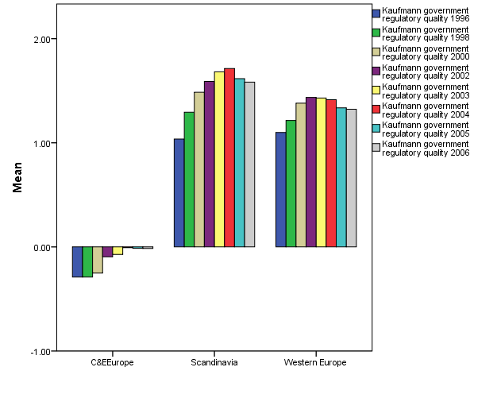
Fonte/Source: Norris (2008).

testo testo testo testo testo testo testo testo testo testo testo testo testo testo testo testo testo testo testo testo testo testo testo testo testo testo testo testo testo testo testo testo testo testo testo testo testo testo testo testo testo testo testo.

